## **AGNI🔥– Advanced Ground-test Node for Ignition**

AGNI is a custom PCB designed for static rocket motor testing. At its core is the **ESP32-S2-WROOM**, which handles ignition safety, sensor interfacing, data logging, and wireless telemetry. Each subsystem was designed with **redundancy, stability, and integration** in mind.

### **1. Power Supply Subsystem**

* **Input:** 7–12 V external battery pack
* **Regulation:**
  + TLV76750 → 5 V for HX711, MAX6675, MicroSD, servo
  + TLV76733 → 3.3 V for ESP32, MPU6050, HC-12
* **Decoupling & Filtering:** ceramic capacitors to stabilize voltage rails
* **Protection:** Reverse-polarity diode and solid ground planes

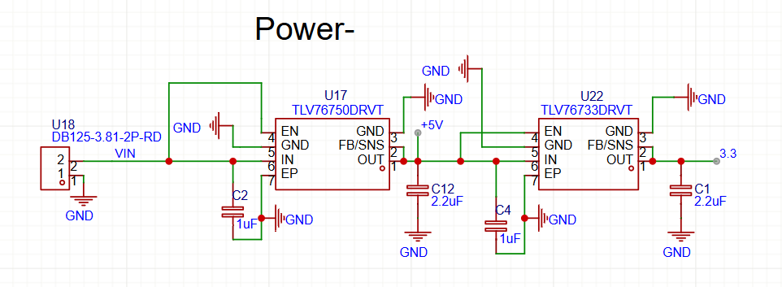

### **2. USB Interfaces**

**Two programming/debugging options:**

* **Native USB (ESP32-S2):** Direct flashing and serial monitoring with TVS diode protection

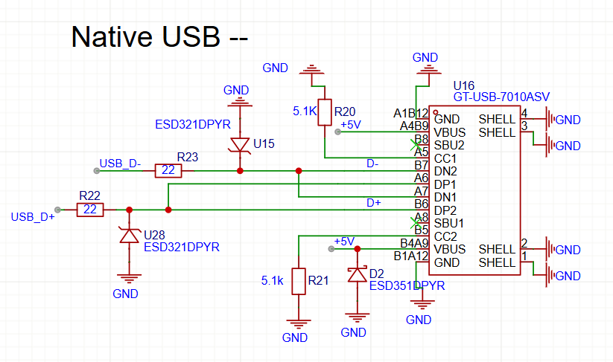

* **UART/FTDI Header:** Secondary programming port via FTDI adapter with auto-reset circuit  
  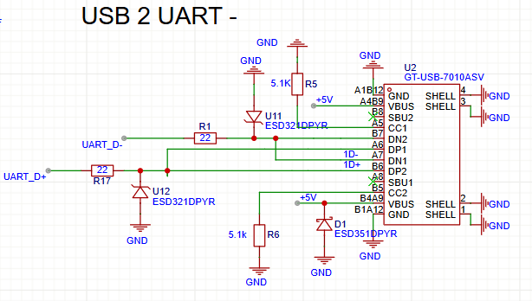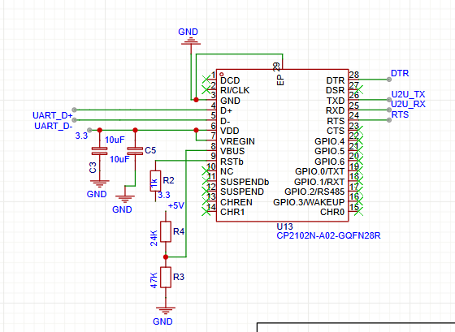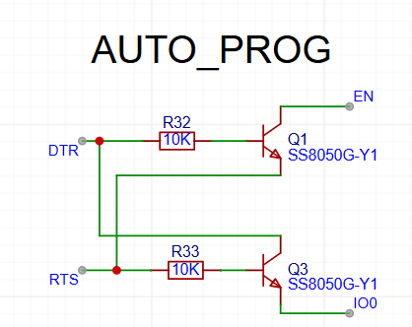

### **3. Microcontroller Core – ESP32-S2**

Manages ignition logic, servo control, sensor data, telemetry, and logging.

* **SPI:** MAX6675 thermocouples + MicroSD
* **I²C:** MPU6050 accelerometer/gyro
* **UART:** HC-12 RF module
* **GPIOs:** MOSFET ignition drivers, arming switches, LEDs, servo PWM

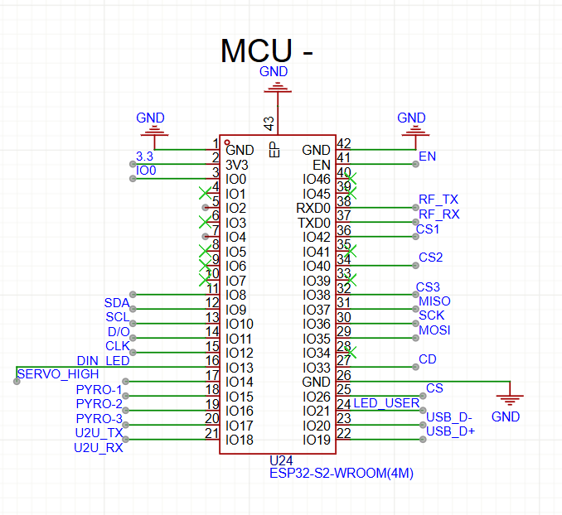

### **4. Ignition Control Subsystem**

* **MOSFET Drivers:** AO3400 MOSFETs with 220 Ω gate resistors and 10 kΩ pull-downs
* **Safety:** Hardware arming switch, software enable logic, and manual acknowledgment button
* **Connections:** Screw terminals for secure e-match attachment

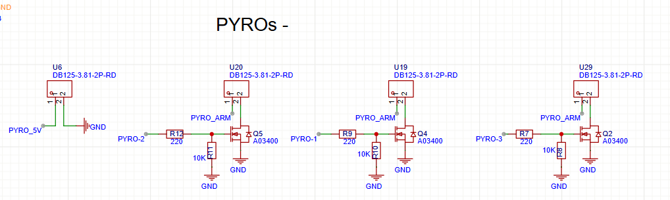

### **5. Servo Subsystem**

* Powered by 5 V regulator, controlled via PWM from ESP32
* Mechanical arming interlock and physical ON/OFF switch ensure controlled operation

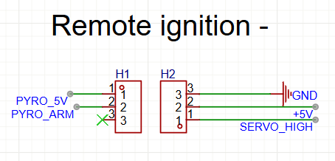

### **6. Sensor Subsystems**

**a) Load Cell (HX711):** High-resolution thrust measurement, DT/SCK connected to ESP32 GPIOs, logic at 3.3 V

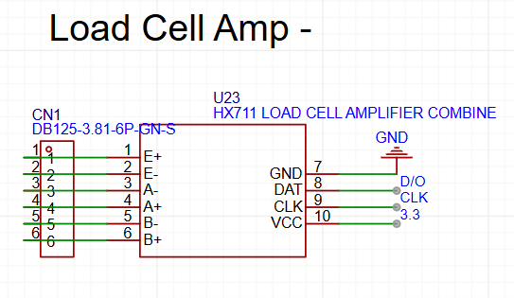

**b) Accelerometer/Gyroscope (MPU6050):** I²C motion sensing for vibration analysis, SDA/SCL connected to ESP32, powered at 3.3 V

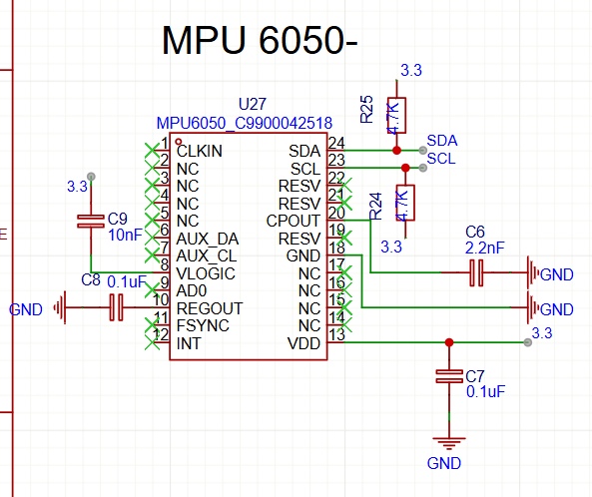

**c) Thermocouples (3 × MAX6675):** SPI with shared MISO/SCK and dedicated CS lines, powered at 3.3 V

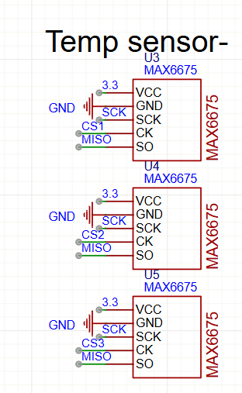

### **7. Telemetry Subsystem**

* HC-12 RF module connected via UART
* Powered at 3.3 V, supports up to 1 km wireless range
* Transmits live thrust, temperature, and system status

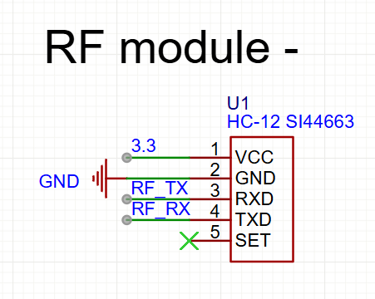

### **8. Data Logging Subsystem**

* MicroSD card module over SPI with dedicated CS pin
* Powered at 5 V with onboard level shifting
* Stores thrust, temperature, and ignition data for post-test analysis

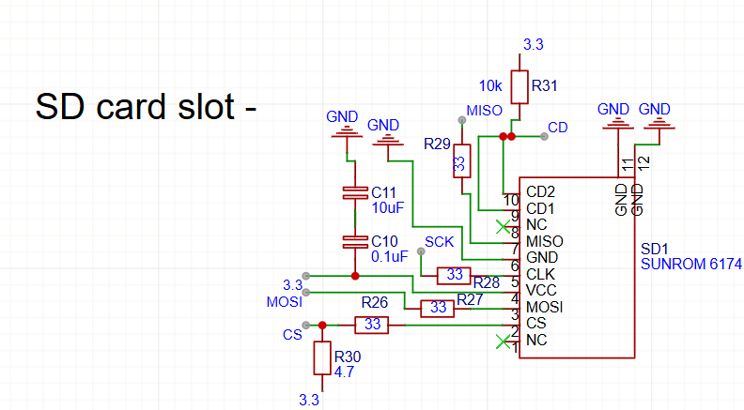

### **9. Indicators & Controls**

* **LEDs:** Power and status/heartbeat indicators

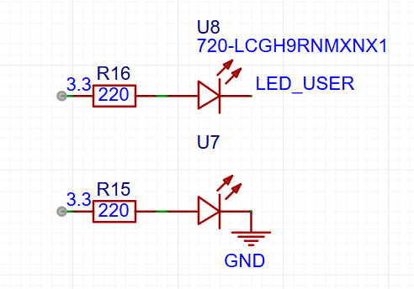

* **Switches:** ESP32 reset, manual ignition acknowledgment, and dedicated arming switch

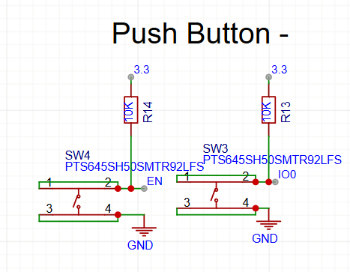

### **10. Testing Line**

### Allows dry-run testing of ignition logic, servo actuation, sensors, and telemetry without triggering pyro channels.

### Provides real-time feedback on voltage rails, sensor readings, and communication links.

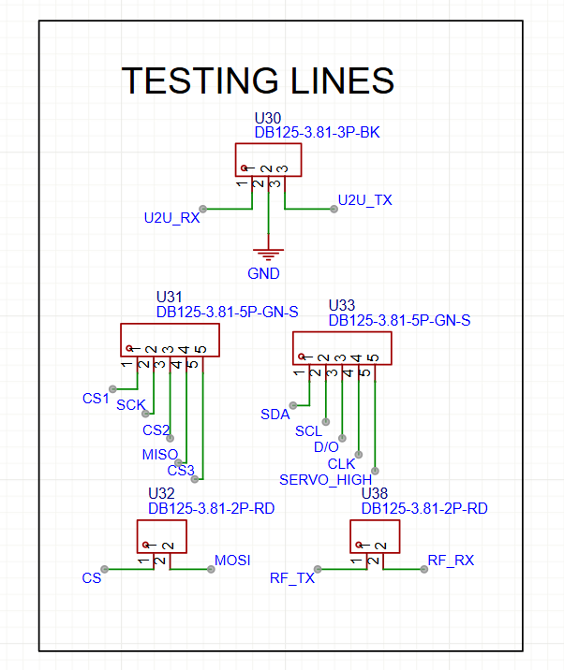

**Blueprint Reflections**

Designing AGNI was an immersive and rewarding journey. Every subsystem presented unique challenges, and each decision taught me something new about electronics design and system integration.

During the power supply design, I initially selected an AMS LDO for regulation. However, after reading a discussion on Reddit about stability and dropout voltage, I switched to the TLV series, which meant rewriting the schematic and rechecking the voltage rail allocations for sensors, servos, and the ESP32.

For the USB interface, selecting the correct resistor values and protection was critical. I first considered standard TVS diodes, but their voltage rating was insufficient for my design, so I switched to ESD321DPYR diodes to ensure reliable ESD and surge protection. Creating the USB-to-UART lines required careful mapping of DTR/RTS signals and auto-reset functionality to allow smooth programming via FTDI.

Working on the sensor subsystems was also challenging. Connecting the HX711 load cell amplifier needed precise wiring between analog and digital voltages. For the MPU6050, I had to rely heavily on the datasheet because of the QFN package, paying special attention to the grounding and decoupling pins to ensure stable I²C communication.

The remote ignition system was inspired by BPS Space’s designs, giving me a real-world reference for safe MOSFET-based pyro control. The RF module integration, SD card interface, and MAX6675 thermocouples for temperature measurement involved learning about SPI bus conflicts, CS line separation, and safe voltage powering. I also integrated features like auto-programming, pushbuttons, and test LEDs after referencing videos and tutorials online.

Designing the PCB layout was a major learning curve. I focused on strategic placement of components, differential trace routing, and minimizing cross-talk between high-current ignition paths and sensitive sensor signals. Each iteration involved improving the routing, optimizing ground planes, and ensuring clear separation of power and signal lines.

Overall, the experience taught me patience, attention to detail, and the importance of research and iteration. I gained practical insights into designing compact, reliable, and safe electronics systems while understanding how each component—from voltage regulators to RF modules—impacts the overall performance of the PCB.